

| **TITLE : To perform VLab on NLP** |
| --- |

**AIM:** Vlab on NLP

**Expected OUTCOME of Experiment:**

CO5: Apply data analytics in the field of Health care.

**_____________________________________________________________________**

**Books/ Journals/ Websites referred:**

Students have to list.

**_____________________________________________________________________**

**Pre Lab/ Prior Concepts:**

Students should have a basic understanding of word analysis.

**Procedure:**

**Vlab Name: Computer Science and Engineering -Natural Language Processing- Word Generation**

**Vlab Link:** [**https://nlp-iiith.vlabs.ac.in/exp/morphology/**](https://nlp-iiith.vlabs.ac.in/exp/morphology/)

Implementation details:

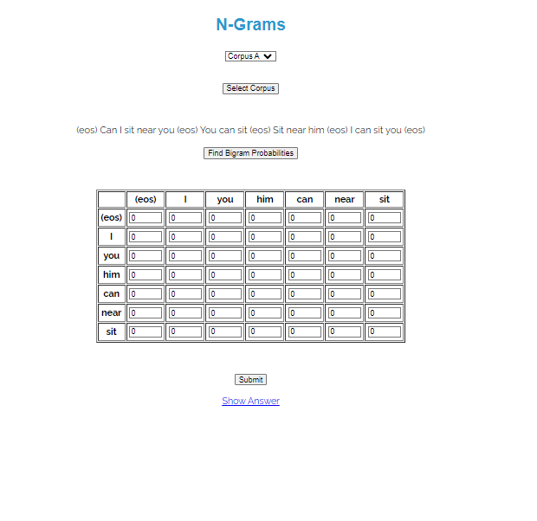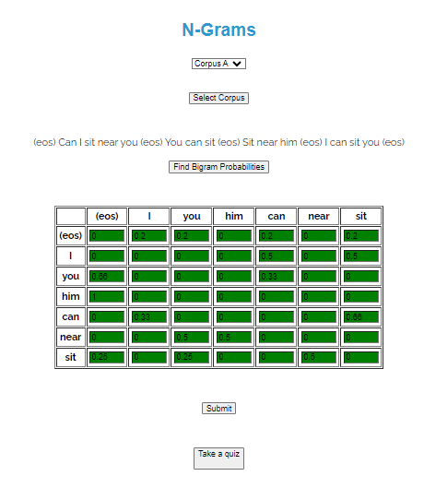

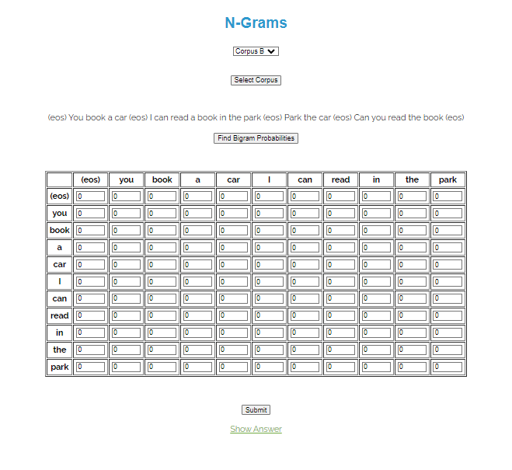

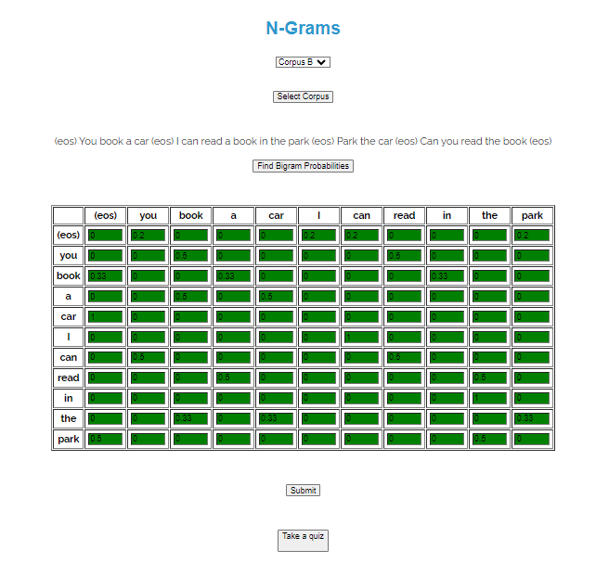



Output:

**Date: _____________ Signature of faculty in-charge**

**Post Lab Descriptive Questions:**

Q.1 Explain various applications of NLP.

Q.2 What is the significance of Natural Language Processing (NLP) in modern technology, and how does it impact various industries?